CHAPTER 6
Anatomy of Flowering Plants
• Anatomy of Flowering Plants

The external morphology of larger living organisms - plants and animals alike - shows clear structural similarities and variations; a study of their internal structure reveals similarities and differences too. This chapter deals with the internal structure and functional organisation of higher plants.
• Anatomy - the study of the internal structure of plants.
Plants have cells as the basic unit; cells are organised into tissues, and in turn the tissues are organised into organs.
• Different organs in a plant show differences in their internal structure.
• Within angiosperms, the monocots and dicots are also seen to be anatomically different.
• Internal structures also show adaptations to diverse environments.
6.1 | The Tissue System

Tissues were earlier discussed on the basis of the types of cells present. Tissues also vary depending on their location in the plant body, and their structure and function are dependent on that location.
The plant tissues are broadly classified into meristematic (apical, lateral and intercalary) and permanent (simple and complex) tissues. Assimilation of food and its storage, transportation of water, minerals and photosynthates, and mechanical support are the main functions of tissues.
On the basis of their structure and location, there are three types of tissue systems:
• the epidermal tissue system,
• the ground or fundamental tissue system, and
• the vascular or conducting tissue system.
6.1.1 | Epidermal Tissue System

The epidermal tissue system forms the outer-most covering of the whole plant body and comprises epidermal cells, stomata and the epidermal appendages - the trichomes and hairs.
The epidermis is the outermost layer of the primary plant body. It is made up of elongated, compactly arranged cells, which form a continuous layer.
• Epidermis is usually single-layered.
• Epidermal cells are parenchymatous with a small amount of cytoplasm lining the cell wall and a large vacuole.
• The outside of the epidermis is often covered with a waxy thick layer called the cuticle, which prevents the loss of water. Cuticle is absent in roots.
Epidermal appendages. The cells of epidermis bear a number of hairs.
• Root hairs are unicellular elongations of the epidermal cells and help absorb water and minerals from the soil.
• On the stem the epidermal hairs are called trichomes. The trichomes in the shoot system are usually multicellular.
• They may be branched or unbranched and soft or stiff; they may even be secretory.
• Trichomes help in preventing water loss due to transpiration.
• Stomata - structures present in the epidermis of leaves that regulate the process of transpiration and gaseous exchange.
• Each stoma is composed of two bean-shaped cells known as guard cells which enclose the stomatal pore. In grasses, the guard cells are dumb-bell shaped.
• The outer walls of guard cells (away from the stomatal pore) are thin and the inner walls (towards the stomatal pore) are highly thickened.
• Guard cells possess chloroplasts and regulate the opening and closing of stomata.
• Sometimes, a few epidermal cells in the vicinity of the guard cells become specialised in shape and size and are known as subsidiary cells.
• Stomatal apparatus - the stomatal aperture, guard cells and the surrounding subsidiary cells together.
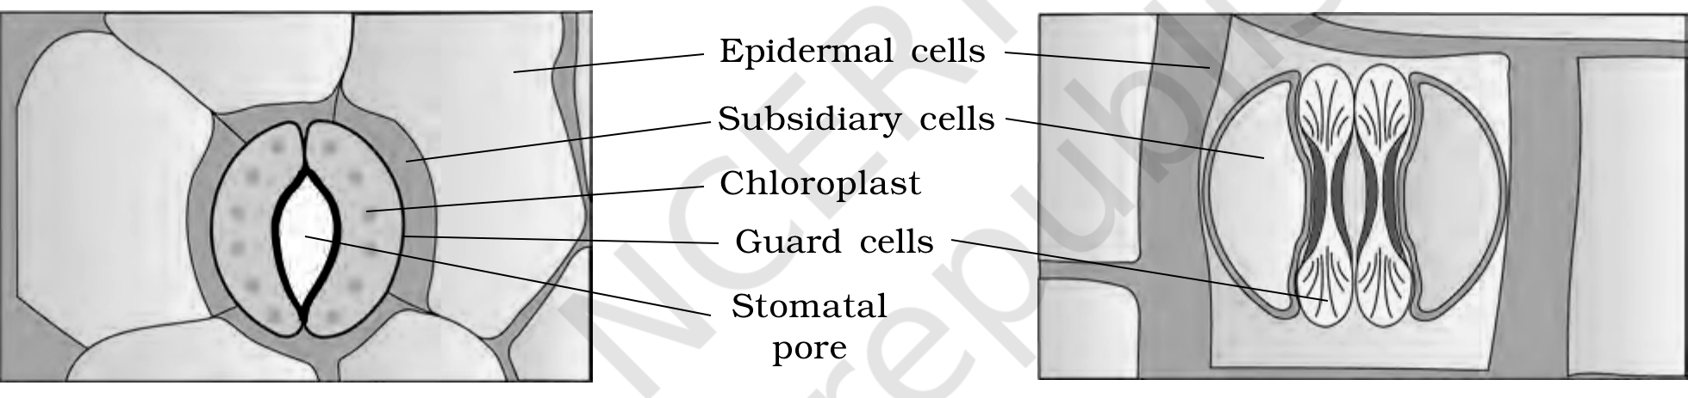
Figure 6.1 Diagrammatic representation: (a) stomata with bean-shaped guard cells (b) stomata with dumb-bell shaped guard cell
[NOTE] Figure 6.1 labels (verbatim): Epidermal cells; Subsidiary cells; Chloroplast; Guard cells; Stomatal pore.

6.1.2 | The Ground Tissue System

All tissues except epidermis and vascular bundles constitute the ground tissue. The ground tissue system forms the main bulk of the plant.
• It consists of simple tissues such as parenchyma, collenchyma and sclerenchyma.
• Parenchymatous cells are usually present in cortex, pericycle, pith and medullary rays, in the primary stems and roots.
• In leaves, the ground tissue consists of thin-walled, chloroplast-containing cells and is called mesophyll.
• The ground tissue is divided into three zones - cortex, pericycle and pith.
6.1.3 | The Vascular Tissue System

The vascular system consists of complex tissues, the phloem and the xylem. The xylem and phloem together constitute vascular bundles. The vascular bundles form the conducting tissue and translocate water, minerals and food material.
Open vs closed vascular bundles (basis: presence of cambium):
• Open - in dicotyledonous stems, cambium is present between phloem and xylem. Because of this cambium these bundles can form secondary xylem and phloem, and are hence called open.
• Closed - in monocotyledons, the vascular bundles have no cambium. Since they do not form secondary tissues they are referred to as closed.
Radial vs conjoint (basis: relative position of xylem and phloem):
• Radial - when xylem and phloem are arranged in an alternate manner along different radii, such as in roots.
• Conjoint - when xylem and phloem are jointly situated along the same radius. Such bundles are common in stems and leaves, and usually have the phloem located only on the outer side of the xylem.
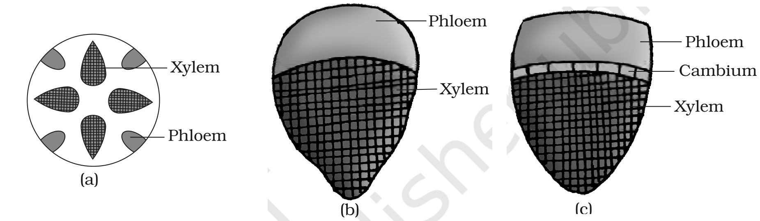
Figure 6.2 Various types of vascular bundles: (a) radial (b) conjoint closed (c) conjoint open
[NOTE] Figure 6.2 labels (verbatim): Xylem; Phloem; Cambium.

6.2 | Anatomy of Dicotyledonous and Monocotyledonous Plants

For a better understanding of tissue organisation of roots, stems and leaves, it is convenient to study the transverse sections of the mature zones of these organs. Secondary growth occurs in most of the dicotyledonous roots and stems.
6.2.1 | Dicotyledonous Root

Figure 6.3 (a) shows the transverse section of the sunflower root. From outside in, the internal tissue organisation is as follows:
• Epiblema - the outermost layer. Many of its cells protrude as unicellular root hairs.
• Cortex - several layers of thin-walled parenchyma cells with intercellular spaces.
• Endodermis - the innermost layer of the cortex; a single layer of barrel-shaped cells without any intercellular spaces. Its tangential and radial walls have a deposition of the water-impermeable waxy material suberin in the form of casparian strips.
• Pericycle - a few layers of thick-walled parenchymatous cells next to the endodermis. Initiation of lateral roots and of vascular cambium during secondary growth takes place in these cells.
• Conjunctive tissue - the parenchymatous cells that lie between the xylem and the phloem.
• Pith - small or inconspicuous in the dicot root.
Vascular tissue and stele.
• There are usually two to four (2-4) xylem and phloem patches.
• Later, a cambium ring develops between the xylem and phloem.
• Stele - all tissues on the inner side of the endodermis, i.e. pericycle, vascular bundles and pith, together.
6.2.2 | Monocotyledonous Root

The anatomy of the monocot root is similar to the dicot root in many respects. It has epidermis, cortex, endodermis, pericycle, vascular bundles and pith.
• As compared to the dicot root (which has fewer xylem bundles), there are usually more than six (polyarch) xylem bundles in the monocot root.
• Pith is large and well developed.
• Monocotyledonous roots do not undergo any secondary growth.
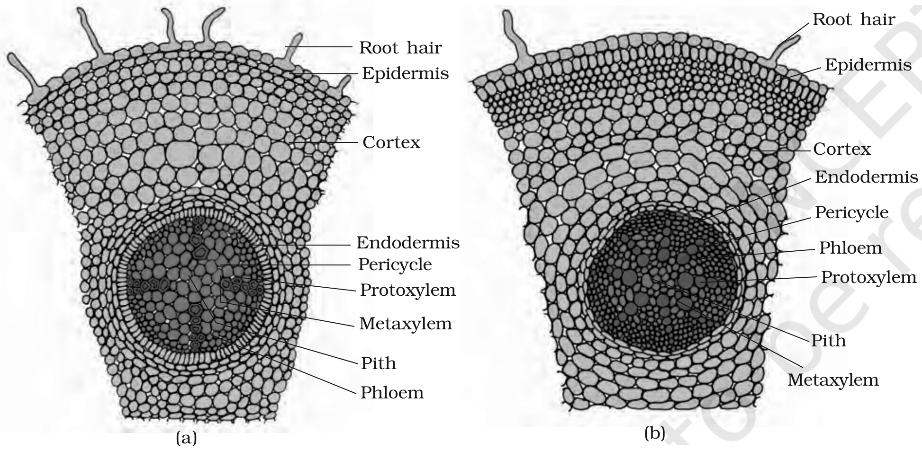
Figure 6.3 T.S.: (a) Dicot root (Primary) (b) Monocot root
[NOTE] Figure 6.3 labels (verbatim): Root hair; Epidermis; Cortex; Endodermis; Pericycle; Protoxylem; Metaxylem; Pith; Phloem.

6.2.3 | Dicotyledonous Stem

The transverse section of a typical young dicotyledonous stem shows the epidermis as the outermost protective layer. Covered with a thin layer of cuticle, it may bear trichomes and a few stomata.
Cortex. The cells arranged in multiple layers between epidermis and pericycle constitute the cortex, which consists of three sub-zones:
• Hypodermis (outer) - a few layers of collenchymatous cells just below the epidermis, which provide mechanical strength to the young stem.
• Cortical layers below the hypodermis - rounded, thin-walled parenchymatous cells with conspicuous intercellular spaces.
• Endodermis (innermost layer of the cortex) - its cells are rich in starch grains, so the layer is also called the starch sheath.
• Pericycle - present on the inner side of the endodermis and above the phloem, in the form of semi-lunar patches of sclerenchyma.
• Medullary rays - a few layers of radially placed parenchymatous cells in between the vascular bundles.
• Vascular bundles - a large number arranged in a ring; this 'ring' arrangement is a characteristic of the dicot stem. Each bundle is conjoint, open, and with endarch protoxylem.
• Pith - a large number of rounded parenchymatous cells with large intercellular spaces occupying the central portion of the stem.
6.2.4 | Monocotyledonous Stem

The monocot stem has a sclerenchymatous hypodermis, a large number of scattered vascular bundles (each surrounded by a sclerenchymatous bundle sheath), and a large, conspicuous parenchymatous ground tissue.
• Vascular bundles are conjoint and closed.
• Peripheral vascular bundles are generally smaller than the centrally located ones.
• The phloem parenchyma is absent, and water-containing cavities are present within the vascular bundles.
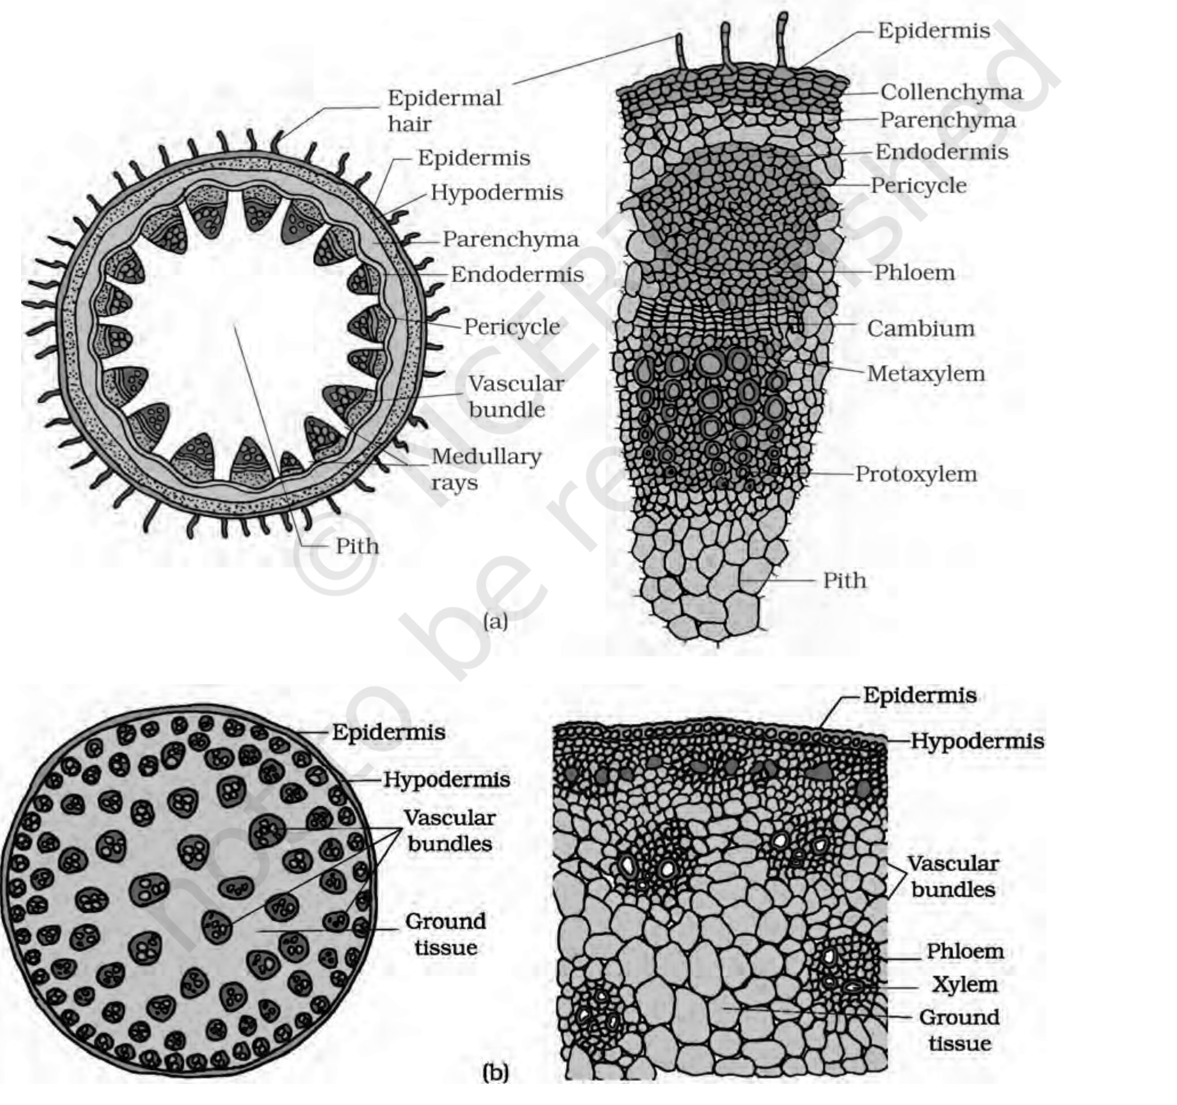
Figure 6.4 T.S. of stem: (a) Dicot (b) Monocot
6.2.5 | Dorsiventral (Dicotyledonous) Leaf

The vertical section of a dorsiventral leaf through the lamina shows three main parts: epidermis, mesophyll and vascular system.
Epidermis.
• It covers both the upper surface (adaxial epidermis) and the lower surface (abaxial epidermis) of the leaf and has a conspicuous cuticle.
• The abaxial epidermis generally bears more stomata than the adaxial epidermis; the latter (adaxial) may even lack stomata.
Mesophyll.
• The tissue between the upper and the lower epidermis is the mesophyll. It possesses chloroplasts, carries out photosynthesis, and is made up of parenchyma.
• It has two types of cells - the palisade parenchyma and the spongy parenchyma.
• The adaxially placed palisade parenchyma is made up of elongated cells arranged vertically and parallel to each other.
• The oval or round, loosely arranged spongy parenchyma lies below the palisade cells and extends to the lower epidermis, with numerous large spaces and air cavities between the cells.
Vascular system.
• It includes vascular bundles, seen in the veins and the midrib. The size of the vascular bundles depends on the size of the veins, and the veins vary in thickness in the reticulate venation of the dicot leaves.
• The vascular bundles are surrounded by a layer of thick-walled bundle sheath cells.
• Note the position of the xylem within the bundle (Figure 6.5 a): the xylem lies towards the adaxial (upper) side and the phloem towards the abaxial (lower) side.
6.2.6 | Isobilateral (Monocotyledonous) Leaf

The anatomy of the isobilateral leaf is similar to that of the dorsiventral leaf in many ways, with the following characteristic differences:
• Stomata are present on both surfaces of the epidermis; and the mesophyll is not differentiated into palisade and spongy parenchyma.
• Bulliform cells - in grasses, certain adaxial epidermal cells along the veins modify into large, empty, colourless cells.
• When the bulliform cells have absorbed water and are turgid, the leaf surface is exposed.
• When they are flaccid due to water stress, they make the leaves curl inwards to minimise water loss.
• The parallel venation in monocot leaves is reflected in the near similar sizes of vascular bundles (except in main veins), as seen in vertical sections.
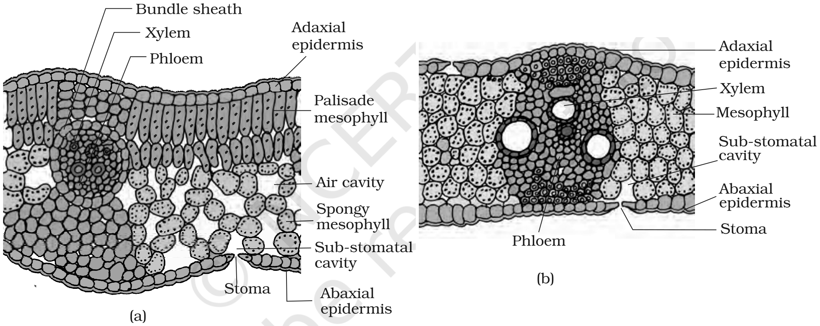
Figure 6.5 T.S. of leaf: (a) Dicot (b) Monocot
[NOTE] Figure 6.5 labels (verbatim): Bundle sheath; Xylem; Phloem; Adaxial epidermis; Palisade mesophyll; Air cavity; Spongy mesophyll; Sub-stomatal cavity; Stoma; Abaxial epidermis; Mesophyll.

Recap | Quick Recap

• Anatomically, a plant is made of different kinds of tissues, broadly meristematic (apical, lateral, intercalary) and permanent (simple, complex). Their main functions are assimilation and storage of food, transport of water, minerals and photosynthates, and mechanical support.
• There are three tissue systems - epidermal, ground and vascular. The epidermal system is made of epidermal cells, stomata and epidermal appendages.
• The ground tissue system forms the main bulk of the plant and is divided into three zones - cortex, pericycle and pith.
• The vascular tissue system is formed by xylem and phloem; on the basis of presence of cambium and location of xylem and phloem the vascular bundles are of different types. They form the conducting tissue and translocate water, minerals and food material.
• Monocots and dicots differ in the type, number and location of vascular bundles, and secondary growth occurs in most dicot roots and stems.
Q | Terms Used in the Exercises

Q6. How is the study of plant anatomy useful to us?
• Anatomy is the study of the internal structure and functional organisation of plants, so it lets us understand how a plant is built from cells to tissues to organs.
• It lets us distinguish monocots from dicots anatomically - within angiosperms the two are internally different - which is how a stem or root is identified from a transverse section.
• It reveals the adaptations of internal structures to diverse environments, e.g. bulliform cells that curl a grass leaf to reduce water loss.

